**Contact:**

Lorena Williams, San Juan National Forest, (970) 422-2939, [Lorena.williams@usda.gov](mailto:Lorena.williams@usda.gov)

Danny Palmerlee, Western Rivers Conservancy, (503)-241-0151, [dpalmerlee@westernrivers.org](mailto:dpalmerlee@westernrivers.org)

**Conserved: Iconic Alpine Meadow and Key Source of Cold Water in the Headwaters of the Dolores River**

*San Juan National Forest acquires 160-acre parcel southwest of Telluride*

*in treasured viewshed of Mount Wilson*

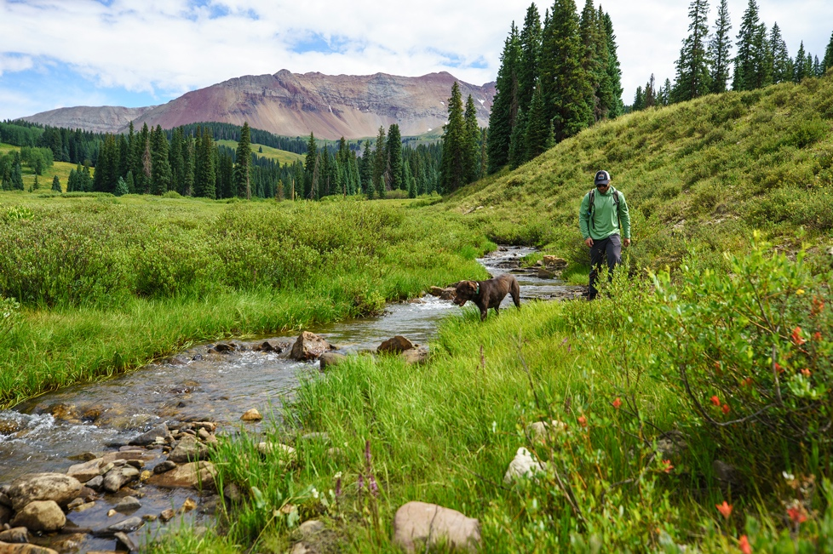

*Dunton Meadows includes .25 miles of the popular fishing stream Meadow Creek.*

*Photo Credit: Christi Bode/Western Rivers Conservancy*

**DOLORES COUNTY, Colorado** (October 30) – The [San Juan National Forest](https://www.fs.usda.gov/sanjuan) Dolores Ranger District and [Western Rivers Conservancy](https://www.westernrivers.org/) (WRC) have permanently conserved the 160-acre Dunton Meadows property—a critically important wetland meadow complex at the headwaters of Colorado’s famed Dolores River. The acquisition protects a crucial source of clean, cold water for Colorado River cutthroat trout in a Dolores River headwater tributary called Coal Creek, and keeps an iconic viewshed intact for people visiting some of Colorado’s most popular hiking trails.

Dunton Meadows sits at roughly 10,000 feet in the San Juan Mountains, 25 miles from Telluride and between the East and West forks of the Dolores. The meadow complex serves as a cold-water sponge that collects, stores, cools, filters, and gradually releases snowmelt and stormwater into Coal Creek, which contains some of the richest habitat in the entire upper Dolores River basin for the Colorado River cutthroat trout. The subalpine meadow is also excellent habitat for Rocky Mountain elk, mule deer, black bear, Canada lynx, American marten and other wildlife.

“In addition to being a spectacular alpine meadow with sweeping views of two of Colorado’s highest peaks, Dunton Meadows is a vital cold-water savings vault for the area’s fish and wildlife,” said Allen Law, WRC’s Interior West project manager. “Alpine wetlands like this are rarer than ever, so protecting what we still have is critical to river systems like the Dolores. We’re thrilled to have worked with the San Juan National Forest to conserve a place that is so integral to the experience that many Coloradans have in this area.”

Dunton Meadows’ sweeping, undisturbed views of Mount Wilson and the Lizard Head Wilderness are emblematic of the area. The property is bisected by an access road that connects hikers to two of Colorado’s most scenic hikes: the Navajo Lake Trail and the Kilpacker Trail. The San Juan National Forest’s acquisition of the property ensures the pristine nature of this mountain meadow and its mountain views remain intact.

“Dunton Meadows is ecologically irreplaceable for the role it serves in the Dolores River watershed,” said Dolores District Ranger Nick Mustoe. “The property’s importance for fish and wildlife in the Dolores River system is only matched by its important contribution to water quality and quantity for downstream municipalities. Places like this allow the National Forest System to live its mission of caring for the land and serving people.”

WRC and the San Juan National Forest launched their effort to conserve Dunton Meadows in 2021, and WRC successfully purchased the property in May 2023. WRC then held the property while working with the Forest Service to secure funding through the Land and Water Conservation Fund and other sources to convey it to the San Juan National Forest.

The Dolores River is one of Colorado’s most popular rivers for anglers and boaters, charting a 240-mile course through alpine meadows, ponderosa pine forests and sheer-walled sandstone canyons. The Dunton Meadows property has been a top priority acquisition for the San Juan National Forest for years, and keeping it intact allows it to continue its small but crucial role in the health of the larger Dolores River system.

*This project was made possible by funding from the Land and Water Conservation Fund. Pivotal support also came from the David and Lucile Packard Foundation and individuals throughout the West.*

*Hi-res images and a map are available* [*here*](https://www.dropbox.com/scl/fo/wz39v6xsvgfv1ao5s8bcn/AIS0Qs-OgWSXAfYvHl9G3zA?rlkey=pmf4rt33h2e2gawhoove0suoy&st=gd5zfqiz&dl=0)*.*

**About the San Juan National Forest**

San Juan National Forest encompasses about 1.8 million acres in the southwestern corner of Colorado. From high-desert mesas to alpine peaks, these federal lands are managed for multiple uses and visitors are asked to respect each other and the natural resources. The San Juan National Forest Headquarters is located in Durango, Colorado, with district offices in Bayfield, Dolores and Pagosa Springs.

**About Western Rivers Conservancy**

Western Rivers Conservancy’s motto is “Sometimes to save a river, you have to buy it.” WRC purchases land along the West’s finest rivers and streams to conserve habitat for fish and wildlife, protect key sources of cold water and create public access for all to enjoy. To ensure the lands it acquires are protected in perpetuity, WRC transfers them to long-term stewards including the U.S. Forest Service, Bureau of Land Management, state parks and Tribal nations. WRC has created sanctuaries for fish and wildlife and secured recreational access along 250 rivers and streams around the West. It has protected more than 440 river miles and over 220,000 acres of land in nine western states. Its approach to river conservation is effective, tangible and permanent. More information at [Western Rivers.org](https://www.westernrivers.org/).